
Managing for Profit

Presented by:
Bill Hassell
Sr. Business Development Consultant
Weichert Real Estate Affiliates, Inc.


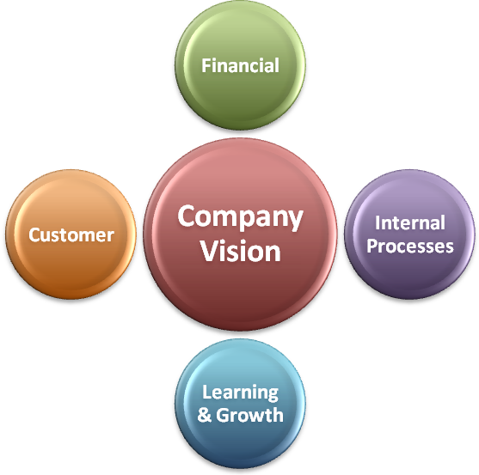
Balanced Scorecard

Financial | Internal Process | Learning & Growth | Customer
Strengths:  Weaknesses:  Opportunities:  Threats: | Strengths:  Weaknesses:  Opportunities:  Threats: | Strengths:  Weaknesses:  Opportunities:  Threats: | Strengths:  Weaknesses:  Opportunities:  Threats:
You Need:
- Profit Loss Statement
- Chart of Accounts for a Real Estate Office
- Basic MLS or Company Sales Info
- Accounting Software (Or Someone Managing Acct)



7 P’s of Marketing
Product | Recruiting
Price | Value of Invested Time
Place | Office
Promotion | Craigs List
People | You / Staff
Process | Incubation  Timing of Ads
Physical Evidence | Handouts

The Plan:

Deadline to Complete Completed
Perform Financial Analysis (SFA Worksheet)
Fill Out BSC / SWOT Forms
Create Target List for Improvement
Use 7 P’s Framework to Design Action Plans
Address Each Challenge

